CATERHAM

VIEWED WITH HUMOUR

RATHER THAN RANCOUR

22545749 JWF Tidridge April to June 1953
23352399 P. Dabbs November 1956-February 1957

BOOKLET 3

INTRODUCTION

The Guards Depot at Caterham, Surrey, UK is a place always remembered by those whose attendance at same was required.

I thought, initially, might be a good idea to have some pictures or cartoons if you like, about the place.
Then I thought why not add text and twist the arms of a couple or three volunteers to add their thoughts.

I already have my own group and they will be asked to contribute...

I would surmise my experiences were much the same as other who attended. Most are kept secret, Most will express pride at having the run the course and not found wanting.

ONCE A GRENADIER, ALWAYS A GRENADIER

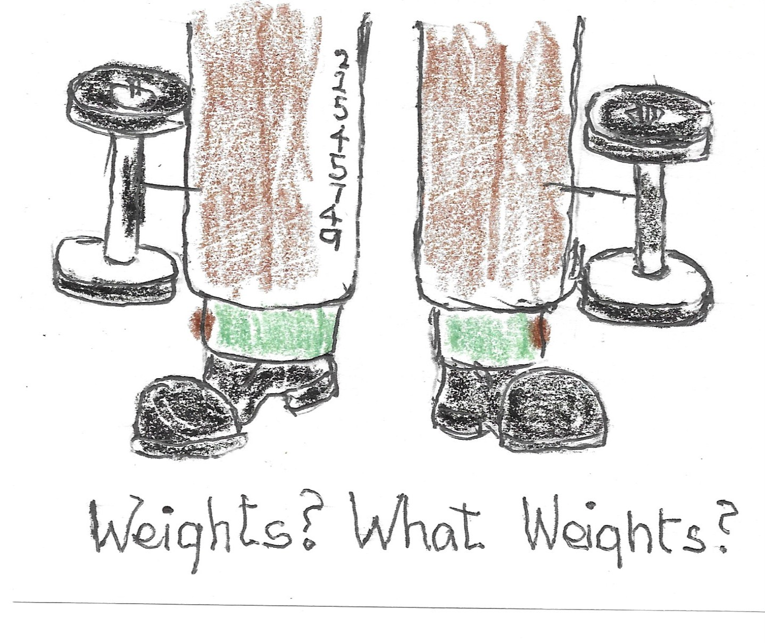
WEIGHTS, AND A WEIGHTY TOPIC Unknown at the depot.

Not sure why I am mentioning this! It was never mentioned at Caterham, but men wearing weights were at in the battalion. For sure at least one Gold Sergeant and a guardsman who came from the RAF Regiment.
Funny how the Windsor knot and weighs were frown upon...but still used surreptitiously.

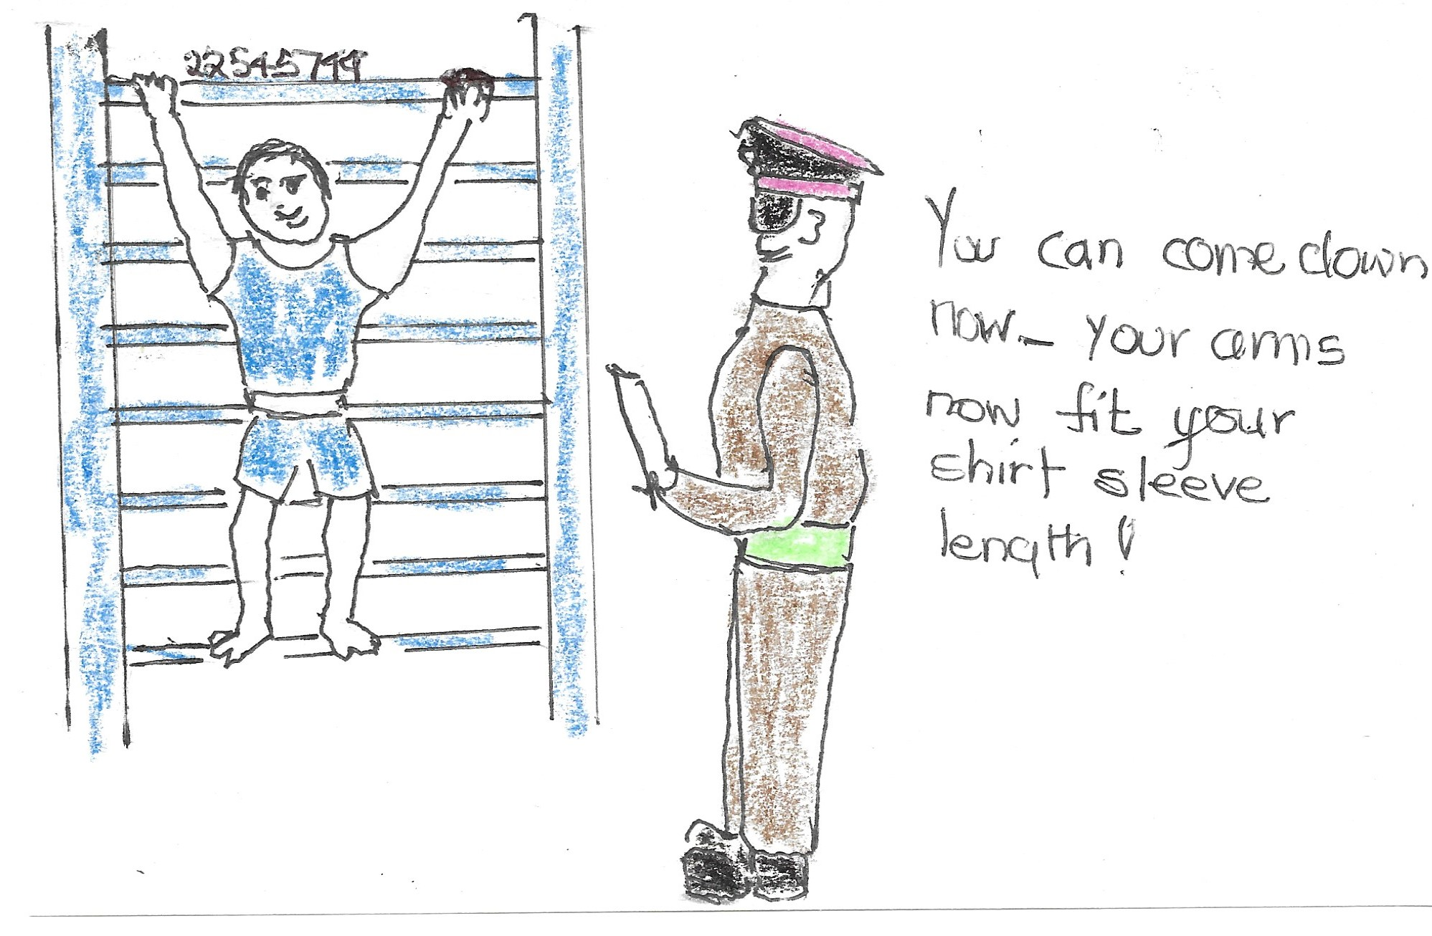
JUST HANGING AROUND There just has to be a reason.
I had no problem with PT [Physical Training] I enjoyed the runs and every aspect of the program. I was reunited with the program when I joined the Edmonton Police Service and the program was identical to the Caterham one. Seriously!

I was volunteered to ‘take on’ another volunteer in a short round of boxing. He was no fool, nor I hoped was I, we sized each other up and just danced around without throwing too much leather. I don’t think the PT Instructor was pleased. Hey, it’s my nose!

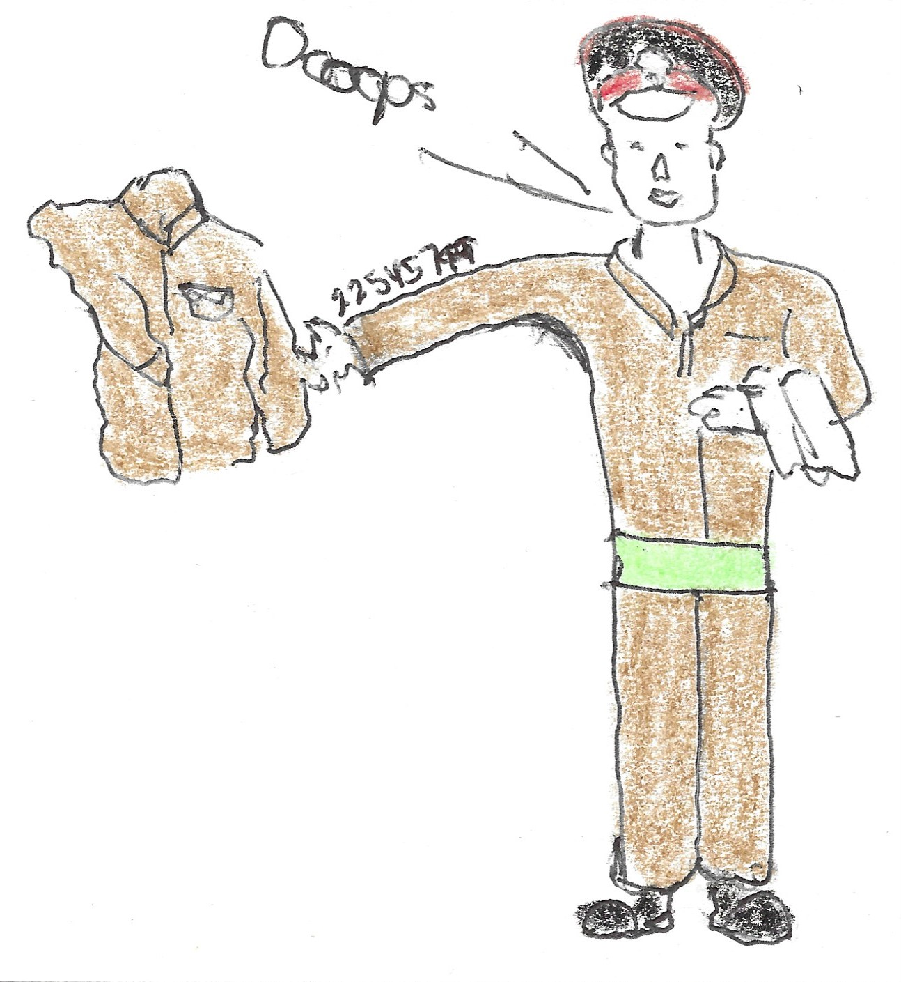
THE FIRST PART OF THE KIT INSPECTION SAGA Sir!
I have mentioned earlier the farcical practice of bed tipping. The action seemed quite logical [they do get to you after a while!]. It gave the officer some idea of the status of your clothing and documentation. And, it det-ermined just how coordinated you were...washing at the wash and on and on...

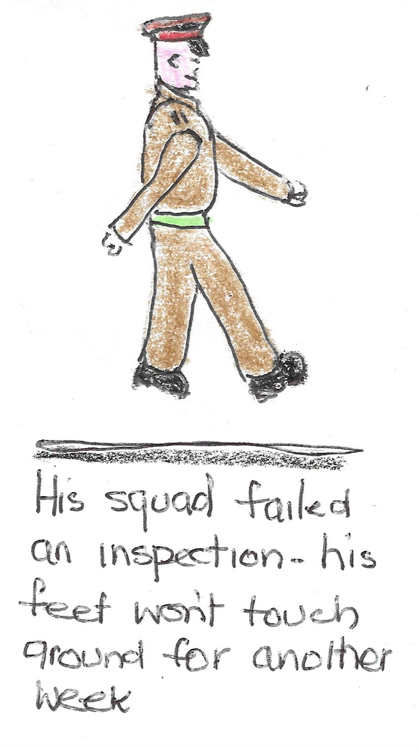
FINALLY..IT WAS WORTH THE SWEAT AND FOR SOME, ACTUAL TEARS.. Words fail me....

